I first used the valley cut notion to create a foldable hinge. Then I attached two straws that were cut to10 cm. Then I created hinges using construction paper to provide a support for the foldable straw. Then I used the foldable straw to rotate the paper and use it as a cover.

Steps taken:

I began the process by folding a sheet of paper in half, creating a precise crease down the center. Next, I employed the classic valley fold technique to refine the shape and structure. With the base ready, I attached two straws to the folded paper, ensuring they were securely fastened. I then created two paper hinges, which would serve as the pivotal points for movement. On each hinge, I affixed a spherical joint straw, allowing for flexible and smooth rotational motion. Finally, I added paper around the spherical joint straws to complete the assembly, integrating all components into a cohesive structure.

1. Maximum Rotation of a Foldable Hinge or Joint

The part a can rotate by maximum three points. The other parts can be rotated by 2 joints.

2. Impact of Rotation Limitations on Mechanism Types

Discussion:

The rotation limit of a hinge impacts the types of mechanisms that can be designed. Hinges with limited rotation angles are suitable for applications requiring simple movements, such as basic folding or opening actions. However, mechanisms requiring continuous or multi-directional movement, like robotic arms or complex gears, might be constrained by these limits

3. Deficiency of Using the Same Material for Links and Joints

Discussion:

Using the same material for both links and joints can lead to several deficiencies. Using paper as links leads to lots of flexible problems. It can also end up tearing which leads to more breakdowns.

4. Strategies to Stiffen a Link

1. Reinforcement with Additional Material:

To make the link stronger we can add metal to the straw to make it more stronger or we can add wooden structure as well.

2. Structural Modifications:

Replace straw with flexible material like elastic polymer which are rigid and flexible. The drawback is that it can complicate the design and may require precise manufacturing techniques to ensure effectiveness.

Strategies to Weaken a Joint

1. Reducing Material Thickness:

Using a thinner sheet of material or cutting out sections from the joint area which makes the joint easier to bend or break, which can be useful for certain mechanical designs or safety features the drawback is it may lead to a less durable joint, which could fail prematurely under stress or load.

2. Introducing Weak Points:

Creating perforations or score lines in the joint area. The advantage is that allows for controlled movement and flexibility in specific directions. The drawbacks is that the joint may become too fragile or prone to damage if not properly managed, reducing overall structural integrity.

Photos

1. Closed image

b) Midpoint open

c) Open image

The Youtube link for the video is mentioned below

[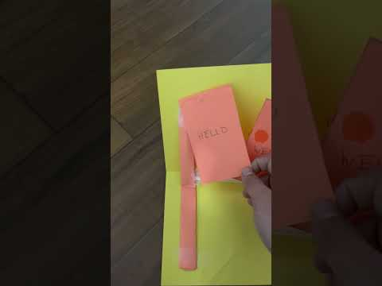](https://www.youtube.com/embed/dd6Misum7cc?feature=oembed)

References

1. *Andrew Glassner Notebook*,Andrew Glassner
2. Peter Engel *,Folding the Universe,*Vintage 1989
3. [Peiwen Yang](https://arxiv.org/search/cs?searchtype=author&query=Yang,+P), [Shuguang Li](https://arxiv.org/search/cs?searchtype=author&query=Li,+S),*Design and Fabrication of String-driven Origami Robots,*2024 IEEE Conference on Robotics and Automation 2024
4. Andrew Glassner*, Interactive Pop up Card Design*,Microsoft Research Technical Report
5. Brian G. Winder,Spencer P. Magleby,Larry L. Howell, *Kinematic Representations of Pop-Up Paper Mechanisms, J. Mechanisms Robotics. May 2009*